# How to use Redis in ASP.NET Core

## Introduction

This sample demonstrates how to use Redis in ASP.NET Core.

## Building the sample

This sample should be run in Microsoft Visual Studio 2015 version.

Before you build the project, make sure you have installed **StackExchange.Redis** package in the project. The following steps can help you to install it:

* Open the solution CSCoreRedis.sln.
* Right click the project and select [Manage NuGet Packages...].
* Search **StackExchange.Redis** from the Browse tab page. Find the right package and then install it.

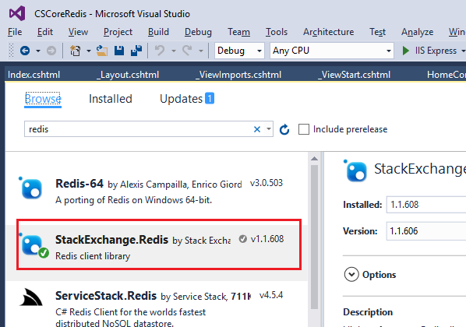

## Running the sample

If you don’t have Redis on your server, download [here](http://redis.io/download).

While the project does not support Windows officially, you can get the Windows port targeting Win64 that developed by Microsoft Open Tech group. See <https://github.com/MSOpenTech/redis>.

Before you run this project, please replace your Redis connection string in the code.

private static Lazy<ConnectionMultiplexer> lazyConnection = new Lazy<ConnectionMultiplexer>(() =>

{

return ConnectionMultiplexer.Connect("localhost,abortConnect=false");

});

Do one of the following:

* Click the Start Debugging button on the toolbar.
* Click Start Debugging in the Debug menu.
* Press F5.

If your Redis service is down. You will see this page

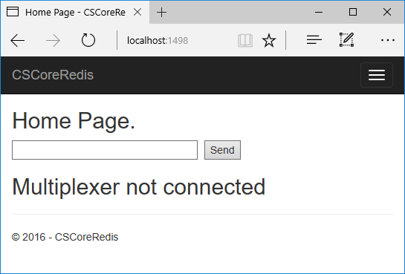

Start the Redis service.

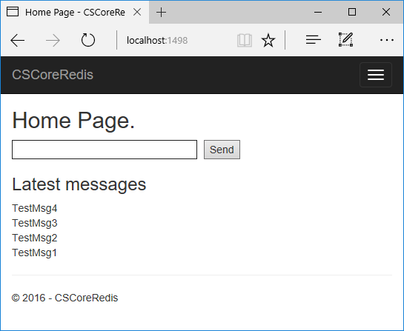

Input some text in the input box

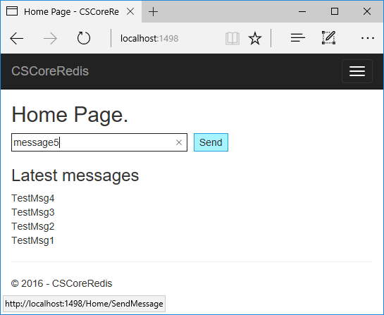

Click send button. The latest messages only show the latest 5 items.

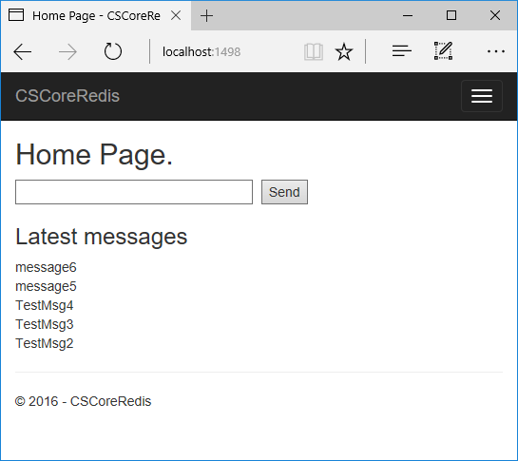

**Using the code**

public HomeController()

{

db = Connection.GetDatabase();

if (db.IsConnected(ListKeyName) && (!db.KeyExists(ListKeyName) || !db.KeyType(ListKeyName).Equals(RedisType.List)))

{

//Add sample data.

db.KeyDelete(ListKeyName);

//Push data from the left

db.ListLeftPush(ListKeyName, "TestMsg1");

db.ListLeftPush(ListKeyName, "TestMsg2");

db.ListLeftPush(ListKeyName, "TestMsg3");

db.ListLeftPush(ListKeyName, "TestMsg4");

}

}

public IActionResult Index()

{

//Get the latest 5 messages.

if (db.IsConnected(ListKeyName))

{

//get 5 items from the left

List<string> messageList = db.ListRange(ListKeyName,0,4).Select(o => (string)o).ToList();

ViewData["MessageList"] = messageList;

return View(messageList);

}

else

{

ViewData["Error"] = "Multiplexer not connected";

return View();

}

}

## More information

[Redis](http://redis.io)

[Redis on Windows](https://github.com/MSOpenTech/redis) by Microsoft Open Tech

StackExchange.Redis [Documentation](https://github.com/StackExchange/StackExchange.Redis)

[Azure Redis Cache](https://azure.microsoft.com/en-us/services/cache/)